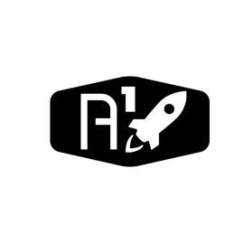

DESIGN DOCUMENT

Area : Converse Engine

Category: Feed (Piping)

TEAM: Propulsion

Nyameaama Gambrah

Ignition System



[This Photo](https://en.wikipedia.org/wiki/File:Valve.svg) by Unknown Author is licensed under [CC BY-SA](https://creativecommons.org/licenses/by-sa/3.0/)

[This Photo](http://commons.wikimedia.org/wiki/File:Expansion_valve.svg) by Unknown Author is licensed under [CC BY-SA](https://creativecommons.org/licenses/by-sa/3.0/)

Electrical

Tap-Off Line Valve

Spark Plug

Igniter Exit

Main Fuel Line Tap-Off

Spark Plug Circuit